Step 5- Pathway Analysis
In this task:
We will visualize the metabolic pathway for ascorbic acid (vitamin c) biosynthesis, highlighting the missing GULO enzyme in humans, and explain biological consequences.
Step 1 – Access KEGG and Reactome pathways
KEGG:
- Go to https://www.genome.jp/kegg/pathway.html
- Search for “ascorbate and aldarate metabolism” or map00053.
- Open the pathway map, which shows all enzymatic reactions from glucose → ascorbate.
Results: 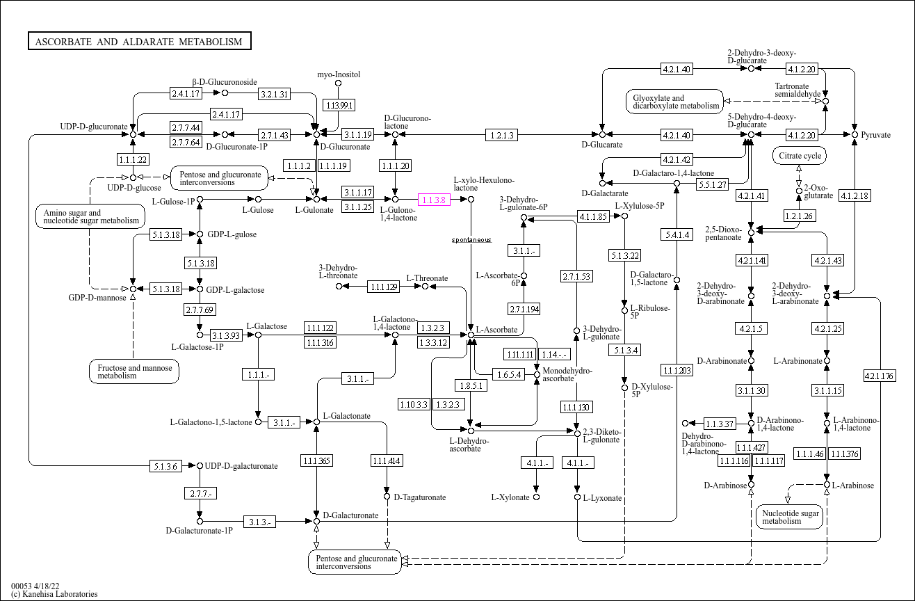
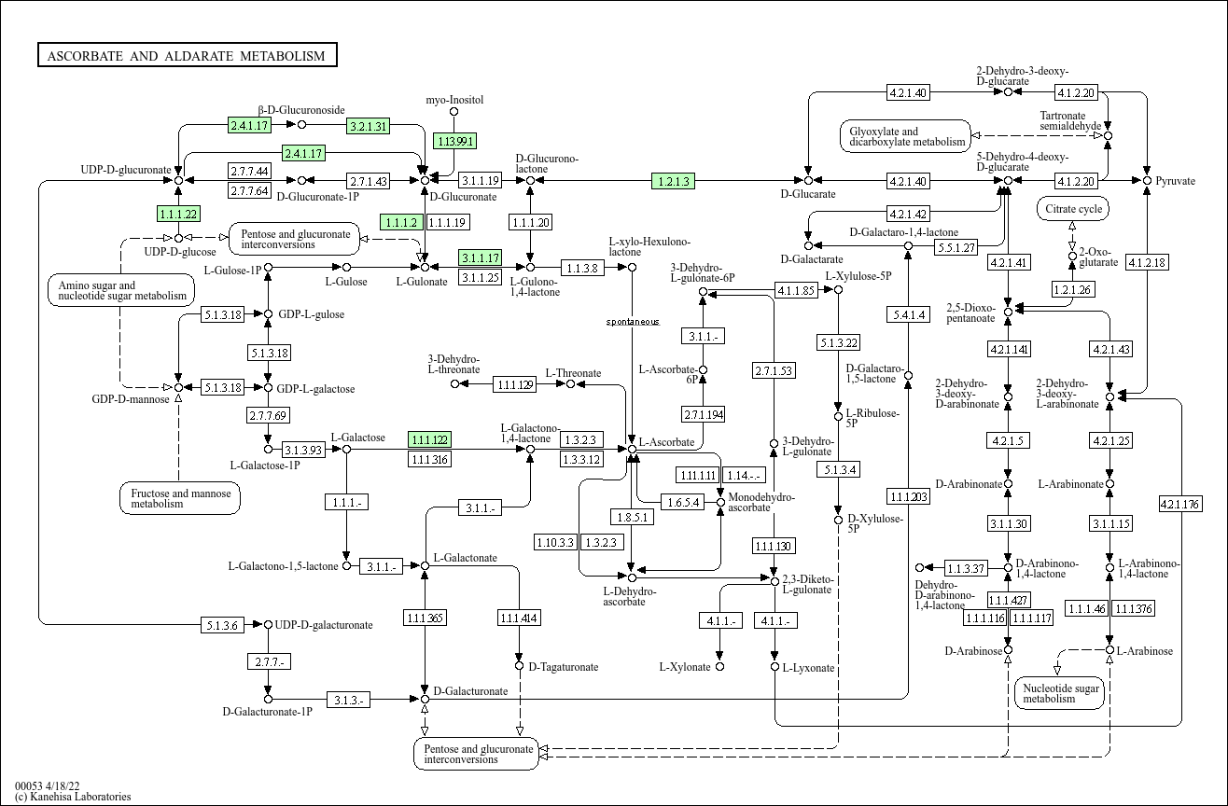
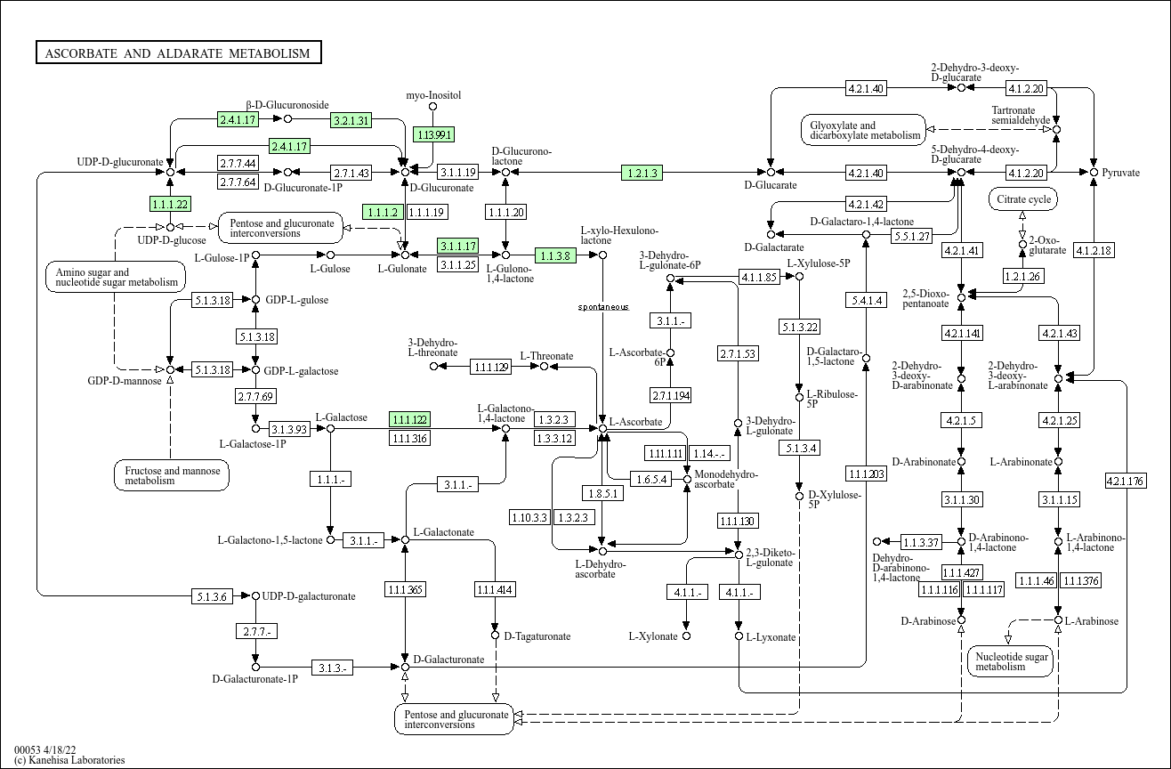

- It can be observed the GULO step is absent on the pathway map for homo sapiens, whereas it is present in that of rattus norvegicus.
- Humans lack a functional GULO enzyme, preventing conversion of L-gulono-1,4-lactone to vitamin C. This explains dietary dependence on vitamin C and impacts collagen synthesis, iron absorption, and antioxidant metabolism.
Step 2 – Downstream Consequences of GULO Absence
GULO is the final enzyme in the vitamin C biosynthesis pathway. Vitamin C (ascorbic acid) is an essential cofactor in several biochemical reactions, so its absence must be supplied dietarily.
- Collagen Hydroxylation and Connective Tissue Integrity:
- Collagen, a major structural protein in skin, blood vessels, bones, and tendons, requires hydroxylation of proline and lysine residues for triple helix stabilization.
- This hydroxylation is performed by enzymes prolyl hydroxylase and lysyl hydroxylase, which require vitamin C as a cofactor.
Without GULO:
- Without endogenous vitamin C, humans rely on dietary sources.
- Vitamin C deficiency leads to improper collagen formation, weakening connective tissue.
- Clinical consequence: scurvy, with symptoms like bleeding gums, fragile skin, delayed wound healing, and joint pain.

- Iron Absorption
- Non-heme iron (from plants) is in the ferric form, Fe³⁺, which is poorly absorbed.
- Vitamin C reduces Fe³⁺ → Fe²⁺ (ferrous), which is more readily absorbed in the intestine.
Impact of GULO loss:
- Humans must obtain vitamin C from diet to maintain iron absorption efficiency.
- Deficiency can lead to iron-deficiency anemia, fatigue, and decreased oxygen transport.

- Antioxidant Recycling and Oxidative Stress
- Vitamin C is a potent water-soluble antioxidant.
- It neutralizes reactive oxygen species (ROS) and regenerates oxidized forms of other antioxidants like vitamin E.
Impact of GULO loss:
- Without GULO, humans rely on dietary vitamin C for antioxidant protection.
- Low vitamin C levels increase susceptibility to oxidative stress, potentially affecting DNA, lipids, and proteins.

